WIA/WIB2003 PROBABILITY AND STATISTICS
TUTORIAL (Poisson Distribution)
1. Consider, in an office 2 customers arrived today. Calculate the possibilities for exactly 3 customers to be arrived on tomorrow.
2. A life insurance salesman sells on the average 3 life insurance policies per week. Use Poisson's law to calculate the probability that in a given week he will sell
- Some policies
- 2 or more policies but less than 5 policies.
- Assuming that there are 5 working days per week, what is the probability that in a given day he will sell one policy?
3. Twenty sheets of aluminum alloy were examined for surface flaws. The frequency of the number of sheets with a given number of flaws per sheet was as follows:
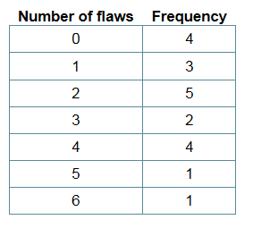
What is the probability of finding a sheet chosen at random which contains 3 or more surface flaws?
4. Vehicles pass through a junction on a busy road at an average rate of 300 per hour.
- Find the probability that none passes in a given minute.
- What is the expected number passing in two minutes?
- Find the probability that this expected number actually pass through in a given two-minute period.
5. The number of visitors to a webserver per minute follows a Poisson distribution. If the average number of visitors per minute is 4, what is the probability that:
(i) There are two or fewer visitors in one minute?
(ii) There are exactly two visitors in 30 seconds?

